**Supermarket Analysis**

**Introduction**

**Objective:**

Conducted market research and analyzed data to understand the preferences, purchasing behaviors of customers and analyzed top products ranks.

**Scope**:

Focused on convenient payment methods and top products categories.

**Methodology**

**Data Collection:**

Data is collected from Secondary source: **Kaggle**

**•** Dataset contains following columns.

1. Invoice ID
2. Branch
3. City
4. Customer type
5. Gender
6. Product line
7. Unit price
8. Quantity
9. Tax 5%
10. Total
11. Date
12. Time
13. Payment
14. cogs
15. gross margin percentage
16. gross income
17. Rating

**Data Analysis**

**Statistical Measures:**

|  | **Unit price** | **Quantity** | **Tax 5%** | **Total** | **cogs** | **gross margin percentage** | **gross income** | **Rating** |
| --- | --- | --- | --- | --- | --- | --- | --- | --- |
| **count** | 1000.000000 | 1000.000000 | 1000.000000 | 1000.000000 | 1000.00000 | 1000.000000 | 1000.000000 | 1000.00000 |
| **mean** | 55.672130 | 5.510000 | 15.379369 | 322.966749 | 307.58738 | 4.761905 | 15.379369 | 6.97270 |
| **std** | 26.494628 | 2.923431 | 11.708825 | 245.885335 | 234.17651 | 0.000000 | 11.708825 | 1.71858 |
| **min** | 10.080000 | 1.000000 | 0.508500 | 10.678500 | 10.17000 | 4.761905 | 0.508500 | 4.00000 |
| **25%** | 32.875000 | 3.000000 | 5.924875 | 124.422375 | 118.49750 | 4.761905 | 5.924875 | 5.50000 |
| **50%** | 55.230000 | 5.000000 | 12.088000 | 253.848000 | 241.76000 | 4.761905 | 12.088000 | 7.00000 |
| **75%** | 77.935000 | 8.000000 | 22.445250 | 471.350250 | 448.90500 | 4.761905 | 22.445250 | 8.50000 |
| **max** | 99.960000 | 10.000000 | 49.650000 | 1042.650000 | 993.00000 | 4.761905 | 49.650000 | 10.00000 |

**Exploratory Data Analysis (EDA):**

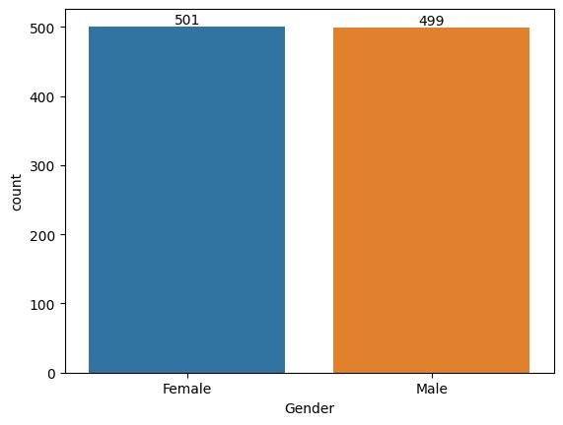

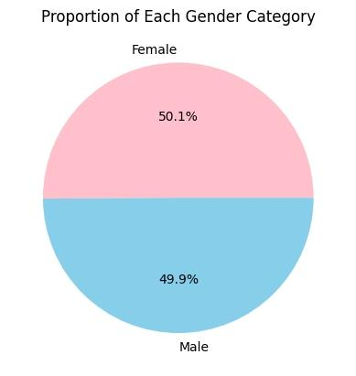

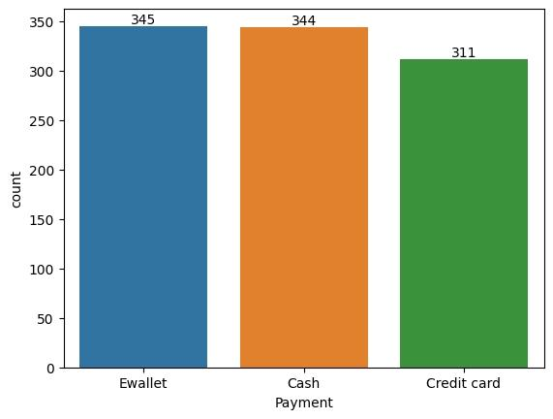

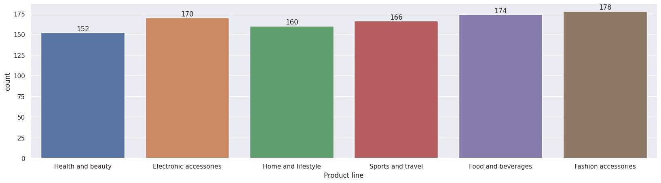

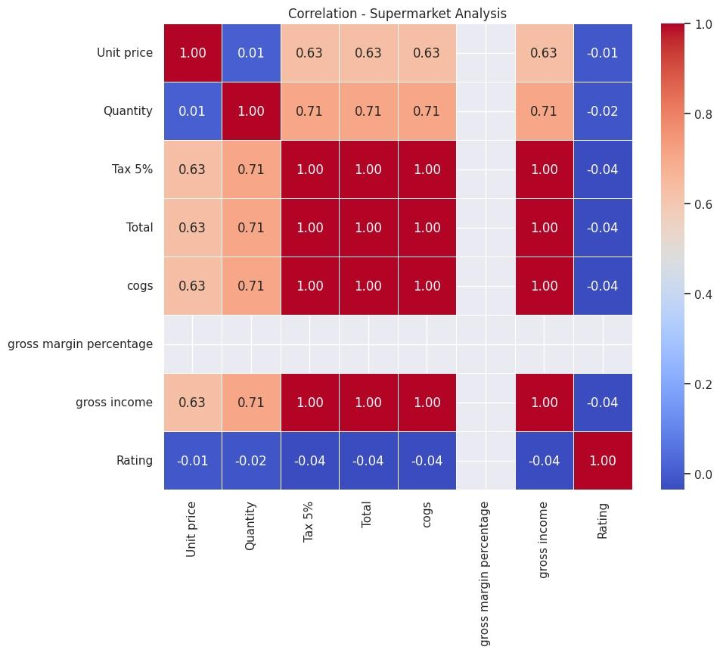

**Findings**

**Male and Female Count**

Male = 499

Female = 501

**Male and Female Ratio**

Male = 49.9%

Female = 50.1%

**Payment Modes**

E-Wallet = 345

Cash Payment = 344

Credit Card = 311

**Top Products Categories**

Fashion accessories = 178

Food and beverages = 174

Electronic accessories = 170

Sports and travel = 166

Home and lifestyle = 160

Health and beauty = 152

**Interpretation of the results / Conclusions**

The results shows that the female ratio is higher than male in the Supermarket store and the E-Wallet payments are more convenient and the customers are more focused towards Fashion accessories, Food and beverages and Electronic accessories.